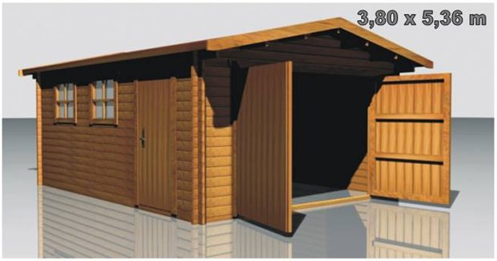
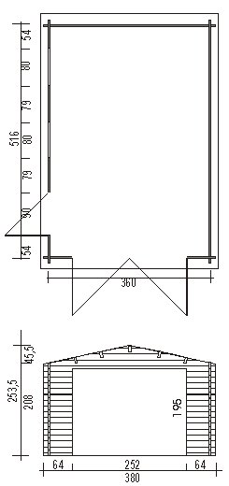
T Garage
£2,025

Consists of:

Walls: sturdy 45 mm double tongue
and groove wall boarding.

Roof: 20 mm tongue and groove roof
boards on the roof beams. . Overhanging
canapy – 40 cm. Roof coating is not included
in the price.

Door: 1 unit 90/185.

Garage door: 1 unit. 240/183 drive-in
hole. Bungs. Without lock.

Windows: 2 units 80/88.

Internal measurements: 3,51 x 5,07 m.

